readFile

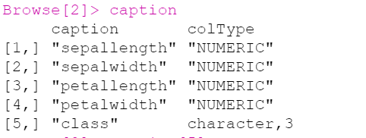

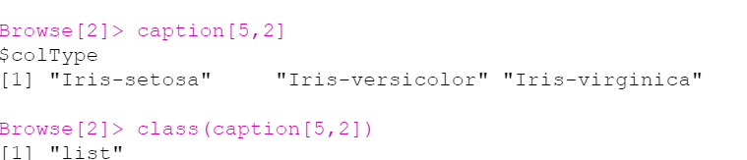

Returns:

D$table_data :

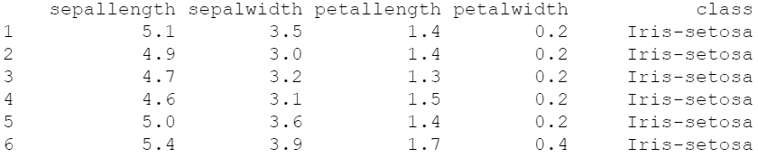

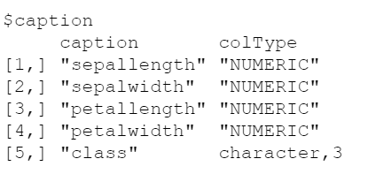

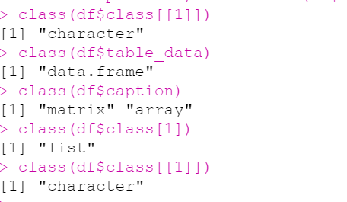

-------------------------------------------------------------------------------------------------

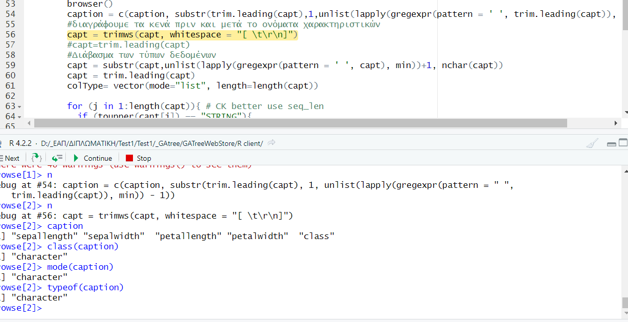

Caption is a vector of chars

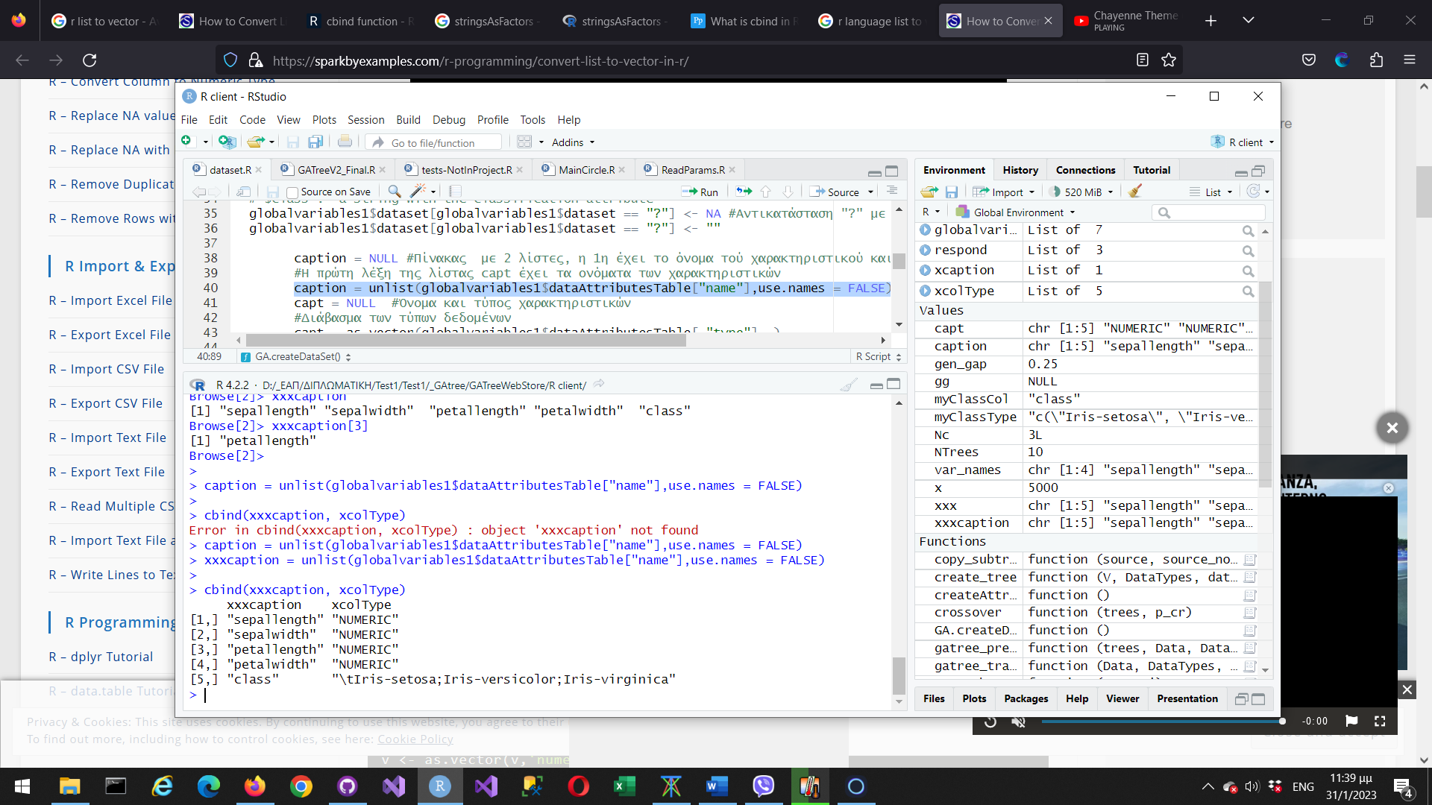

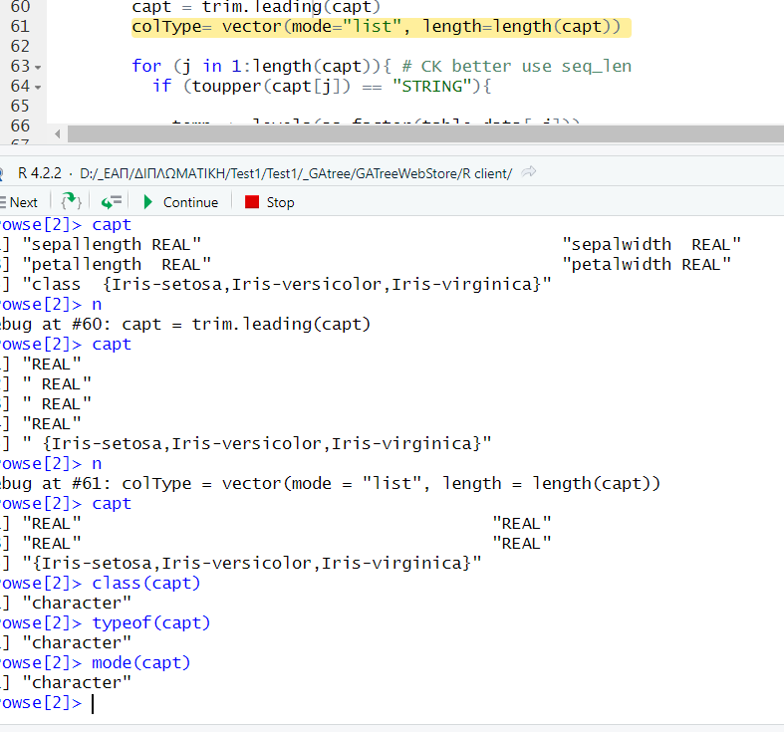

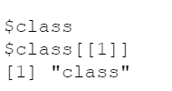

Create_tree

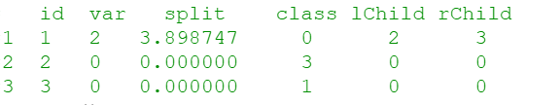

Id:

Var: the datatype sn

Split: The split value between the two children – 0 if they are children

Class: The class – 0 if the nodes aren’t leaves

Lchild, rchild: the sn of the left and right child respectfully

Crossover

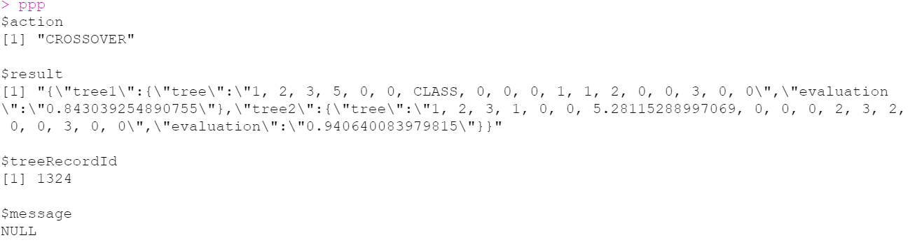

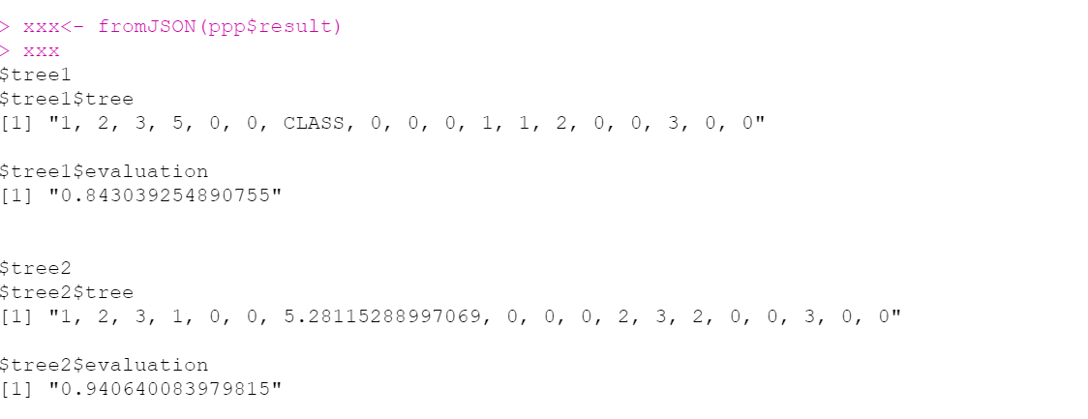

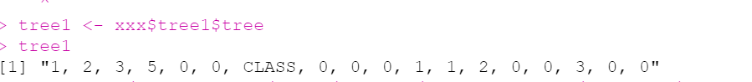

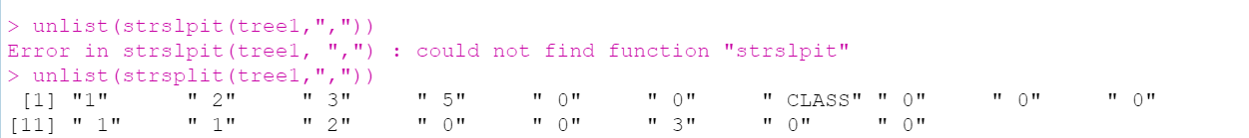

Globalvariables1

|  |  |  |  |
| --- | --- | --- | --- |
| **Name** | **Type** | **Remarks** | **Function produced** |
| url | Chr | The URL |  |
| Datarun | Chr | The datarun ID |  |
| parameters | List | The parameters from the web site |  |
| ExtraParameters | dataframe | The extra parameters |  |
| Dataset | Dataframe | The dataset |  |
| dataAttributesText | Chr | The attributes in text |  |
| dataAttributesTable | Dataframe | The attributes In table |  |
| Guid | Chr | Guid |  |
| clientDataAttributesTable | Vector of character |  | Ιακωβάκης |
| ClassName | Chr |  | Ιακωβάκης |
| ClassType | Chr |  | Ιακωβάκης |
| varNames | Vector of character |  | Ιακωβάκης |